API DOCUMENTATION
1) User registration

url : {domain}/api/users

type : POST

parameters :
name | required
email | required
password | required
role_id | required

Sample response :

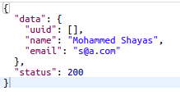

2) Get client secret

url : {domain}/api/oauth/clients

type : POST

parameters :

id | required
name | required

Sample response:

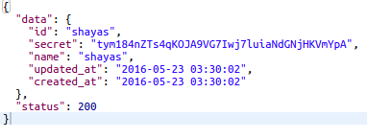

3) User login

url : {domain}/api/oauth/authorize

type : POST

parameters :

username | required
password | required
grant_type | password
client_id | required
client_secret | required

Sample response :

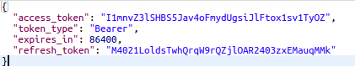

4) Create Project

url : {domain}/api/project

type : POST

parameters :

title | required
content | optional
access_token | required

Sample response :
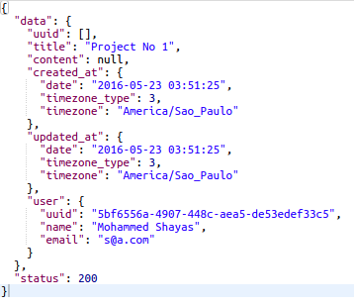

5) Edit Project

url : {domain}/api/project/{uuid}

type : PUT

parameters :

title | optional
content | optional
access_token | required

Sample response

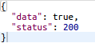

6) Delete Project

url : {domain}/api/project/{uuid}

type : DELETE

parameters :

access_token : required

Sample response

7) Create Message

url : {domain}/api/message

type : POST

parameters :

title | required
project_id | required(uuid)
parent_id | optional(uuid)
keywords | optional
contents | optional
access_token | required

Sample response

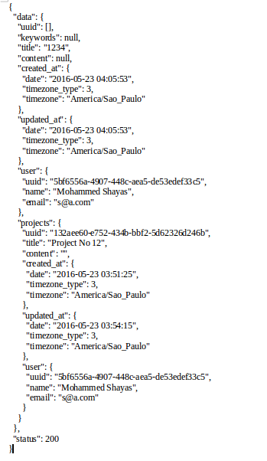

8) Edit Message

url : {domain}/api/message/{uuid}

type : POST

parameters :

title | optional
project_id | optional(uuid)
user_id | optional(uuid)
parent_id | optional(uuid) – message parent
keywords | optional
contents | optional
access_token | required

Sample response

9) Delete Message

url : {domain}/api/message/{uuid}

type : DELETE

parameters:
access_token : required

Sample response :

10) Keyword Process

url : {domain}/api/message/process

type : POST

parameters:

access_token : required
data : {"data":[{"project": "747cab73-3000-4f72-b8f6-17860ae595a4","text":"bla bla develop an API bli bli","macrofields":[{ "name":"Mohammed Shayas", "country": "India"}]},{"project": "747cab73-3000-4f72-b8f6-17860ae595a4","text":"bla bla develop an API bli bli","macrofields":[{ "name":"Cassio", "country": "Brazil"}]}]}

Sample response :

